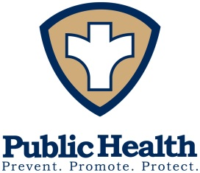
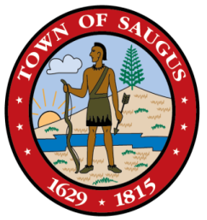
TOWN OF SAUGUS
BOARD OF HEALTH
298 CENTRAL STREET, SUITE 9
SAUGUS, MASSACHUSETTS 01906

Board of Health Telephone: (781) 231-4120
John R. Fralick, III RS/REHS (781) 231-4117
Director of Public Health jfralick@saugus-ma.gov

When to use your self-test:
- Consider using your COVID-19 self-test prior to attending any large gatherings this holiday season. This is especially important if you are attending an even with any unvaccinated persons/children, or anyone that may be immunocompromised.
- Consider using your COVID-19 self-test if you know you have been exposed to someone with COVID-19
How to use your self-test:
- Follow the instructions included with your COVID-19 self-test kit.
- Having trouble? Please scan the QR code to watch a simple YouTube tutorial with clear instructions.
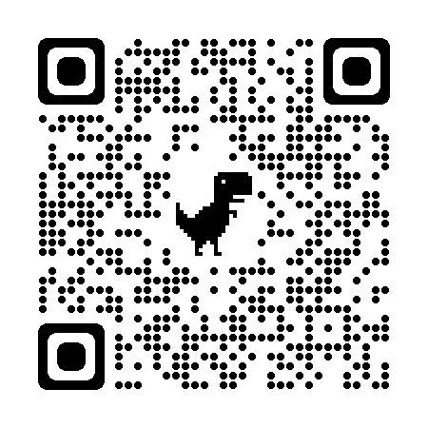
My test came back positive, what should I do?
- Call your primary care physician.
- Begin isolation immediately.
- Inform all close contacts (people you have been in immediate contact with for more than 15 minutes over the past 48 hours).
- Please visit Saugus-MA.gov for further information!

